Florida Section
Society for Range Management
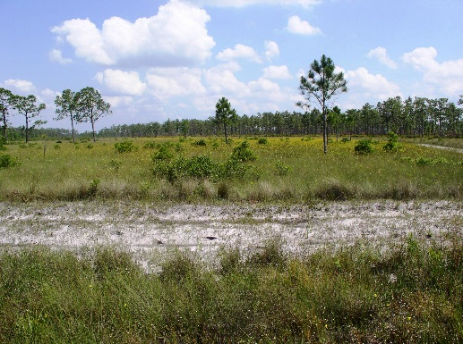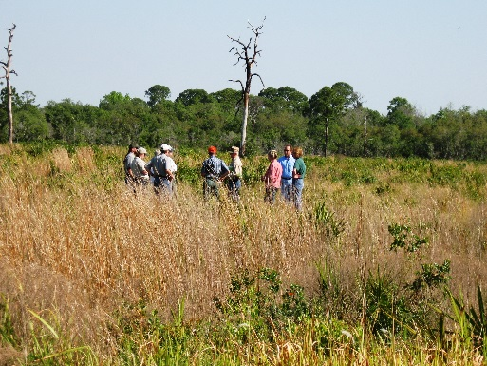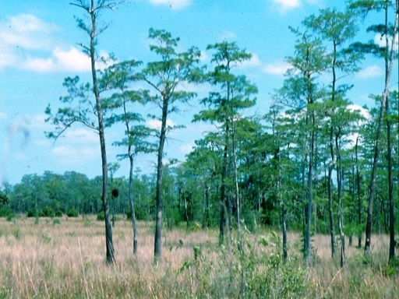
Spring Workshop
WHEN: April 23, 2015
WHERE: Osceola County Extension Services Building
1921Kissimmee Valley Lane, Kissimmee, Florida
TOPICS TO BE DISCUSSED:
Identification of Common Introduced Forage Grasses
Praxelis clematidea in Florida
Introduction to Raoul Boughton, UF- IFAS Range Scientist
Introduction to NRCS State Rangeland Management Specialist
Soil Health Overview and Research Update
Coyote Research Update
USDA Conservation Programs Overview: EQIP and CSP
USDA Conservation Programs Overview: Easements
Using Manure to Assess Forage Quality of Grazing Cattle
Cows Eat Weeds
Managing Smutgrass Without Herbicides

Steak Lunch Provided with Registration
For additional information contact: Pete Deal (407) 847-4465 ext. 107

Florida Section- Society for Range Management 2015 Spring Workshop
Osceola Extension Services Workshop
Thursday, April 23, 2015
SRM Member: $20.00 | Non-SRM Member: $35.00
Late Registration: $50.00
Please Specify:
Name: | Company Name:
Address:
Phone: | E-Mail:

Please fill out the form above and mail with a check to:
Brandee Williams
9036 White Sage Loop
Bradenton, FL 34202

