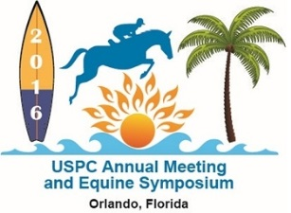
Equine Education Day 2016
Presented by UF College of Veterinary Medicine and Sunshine Region Pony Clubs
Saturday January 23, 2016 8:45 AM
The USPC, Inc. Sunshine Region Pony Clubs, in conjunction with The College of Veterinary Medicine in Gainesville, is proud to offer our semi- annual Equine Education Day. This event is open to all equine enthusiasts. Attendance is based on a first come first served basis and attendance is limited to 100 participants.
Location: UF Large Animal Clinic, 2015 SW 16th Ave, Gainesville, FL 32610
Format and Topics: Please see attached schedule.

Registration:
- Completed forms (next page) and payments must be received by Friday, January 15, 2016. Please note, this is not a postmark date. All forms and fees must be received by this date for attendance to this event.
Pony Club DC’s do NOT need to send your club forms and fees together in a packet (unless you want to )– each person can send in their own form.

2016 Equine Education Day Registration Form (one per person)
Form, with fee must be received by Friday, January 15, 2016.

Name:_____________________________________________________
Age (if under 18)_________Pony Club Member: _____Pony Club Parent: ___________
Pony Club Name: ____________________USPC Rating Level:_________
No Pony Club affiliation: _______________
Contact Email address: _____________________________

Contact phone number:_____________________________
We will be splitting into 3 groups for the afternoon. Please specify if you prefer to be grouped with a particular person or adult:______________________
Lunch: Circle one sandwich selection below. Soda/water/ hot chocolate/coffee will be provided. Lunch also includes chips and a dessert.

Ham sandwich Turkey Sandwich
Fees:
$15.00 USPC, Inc/SRPC members in good standing for 2016, with all National, Regional and Club fees paid for 2016.
$25.00 All others: Parents, siblings, Non-Pony Club individuals

Send this registration form with a check made out to Sunshine Region Pony Clubs to:
Sharon Hiemenz, VRS 4205 NW 30th Terrace, Gainesville, Florida 32605
Once registration has been received, refunds are not available.
Please contact Sharon Hiemenz, VRS, with any questions: 352-317-1621 Sharon_Hiemenz@hotmail.com

